BANKING CLIENTS DATA ANALYTICS
REPORT
Workflow: Excel → SQL → Power BI
1. Overview
This project analyzes banking client data to understand customer segments, deposits, loans, business lending, advisor performance and risk. The analysis follows an end-to-end data analyst workflow: data preparation in Excel, analytical queries in SQL, and dashboard visualization in Power BI.

2. Excel – Data Preparation
The raw banking client dataset was prepared in Excel before analysis. The final dataset contains customer demographics, income, deposits, loans, credit-card balances, business lending, relationship type, loyalty classification, fee structure, risk weighting and advisor information.
Key preparation activities:
- Reviewed column names and data types.
- Checked customer, demographic and financial fields for consistency.
- Prepared the clean banking-client dataset for SQL analysis and Power BI.

3. SQL – Business Analysis
SQL views were created to answer the main business questions. The project includes segment-value analysis, risk-versus-loan/credit analysis and customer deposit ranking.

4. Power BI Dashboard
The Power BI dashboard converts the SQL outputs into interactive business visuals.
Implemented views include:
- KPI cards: Total Clients, Total Deposits, Total Loans and Total Credit Card Balance .
- Banking Relationship analysis using deposits, loans and business lending.
- Loyalty Classification × Fee Structure segment analysis.
- Risk Weighting analysis for average loans and credit-card balances.
- Top customers by net worth/deposits using ranking or Top N filtering.
- Investment Advisor analysis using client count and financial measures.
- Slicers for Nationality, Fee Structure, Gender, Loyalty Classification, Banking Relationship and Age to
support interactive analysis.

5. Key Business Questions

1. What does the client base look like by age, gender and nationality?

- Overall Dataset
- The dataset contains 2,940 clients across 27 columns after cleaning process.
- There are 4 banking relationship types, 4 loyalty classifications and 3 categories of fee structure.
- Risk weighting ranges from 1 to 5,useful for risk segmentation.
- There are 22 investment advisors, giving enough scope for advisor-performance analysis.

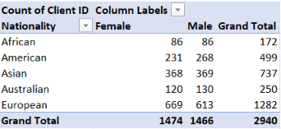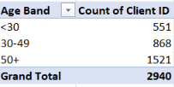

- Clients overview
- There are 2,940 clients; 1,474 are females and 1,466 are males from various nationalities but top 2 nationalities are European(1282 clients) and Asian(737 clients).
- The client base is strongly concentrated among mid-age and older customers.

2. Which loyalty classification and fee structure segments hold the most deposits?
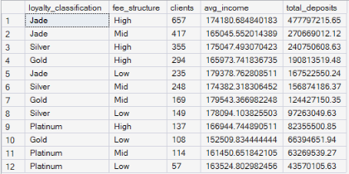
Jade + High Fee is the strongest segment, with 657 clients and approximately $47.77 crore in total deposits
and $50.44 crore in net worth.
Here are the top 3 :
Segment | Clients | Avg. Income | Total Deposits
Jade – High | 657 | $1.74 lakh | $47.77 crore
Jade – Mid | 417 | $1.65 lakh | $27.06 crore
Silver – High | 355 | $1.75 lakh | $24.07 crore

3. How does risk weighting relate to loans and credit-card balances?
There is a strong upward pattern: as Risk Weighting increases from 1 to 5, average bank loans and average credit-card balances also increase. Risk 5 has the highest average loan ($9.68 lakh) and credit-card balance ($5259), while Risk 1 has the lowest.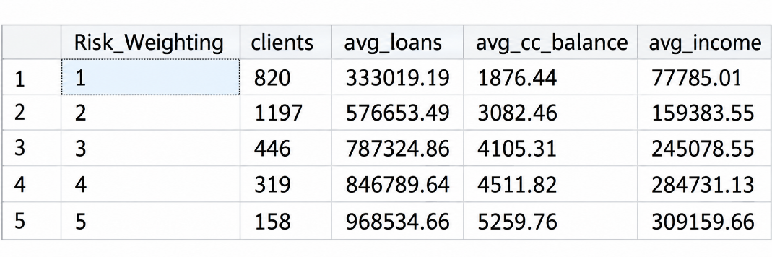
4. Which banking relationship drives the most deposits, loans and business lending?
Private Bank is the leading relationship type, with 1,323 clients and approximately $90.90 crore in deposits. It also has the highest total business lending at approximately $79.39 crore and total loans of $114.3 crore.
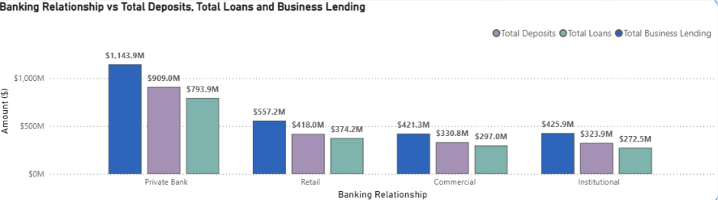

Relationship | Clients | Total Deposits | Business Lending
Private Bank | 1,323 | $90.90 crore | $114.39 crore
Retail | 648 | $41.80 crore | $55.72 crore
Commercial | 484 | $33.08 crore | $42.13 crore
Institutional | 485 | $32.39 crore | $42.59 crore
5. Who are the top customers by net worth?

Net worth of top 10 clients varies from $8.60M to $5.08M.
Combine net worth of top 10 clients is $58.04M(2.85%) out of total net worth $2032.5M and Damiel Gomez is on the top with net worth of 8.60M.

6. Who are the top investment advisors by net worth managed?

Top 10 investment advisors are managing worth around $1245.22M .
Peter Castillo is on the top with $137.83M.

6. Final Findings
- Private Bank is the most valuable relationship segment by total deposits and business lending.
- Jade–High Fee is the strongest loyalty/fee combination by total deposits.
- Risk Weighting shows a clear positive relationship with average bank loans and credit-card balances.
- Higher-risk customers should receive closer monitoring because of greater lending and credit exposure.
- Customer ranking and advisor-level analysis can help identify high-value customers and support relationship-management decisions.
- Power BI provides an interactive layer for management to explore these findings by customer and segment dimensions.

7. Conclusion
The project demonstrates a complete data analytics workflow from Excel data preparation to SQL-based business analysis and Power BI visualization. The analysis provides actionable insights into customer value, deposits, lending exposure, risk and relationship segments, supporting data-driven banking decisions.

